**FULL STACK JAVA DEVELOPMENT**

**FINAL PROJECT**

**PROJECT OVERVIEW**

This is the overview of the placement agency web application designed to help the employee and the employer to satisfy their requirements. For the employee, to find their best suited employer and the employer to short list their employee based on the employee’s skills.

**ENVIRONMENTAL SETUP**

The project is developed in Eclipse IDE using the Java Server Pages(JSP) and servlets. The server used in the application is Tomcat 9.0. Oracle SQL is the database used in the application to store and retrieve the data’s required in the application.

The packages included are

* Servlet-api.jar
* Ojdbc6.jar
* Mysql-connector-java-8.0.16.jar
* Jstl-1.2.jar
* Jstl-api.jar
* Jstl-impl.jar
* Jstl.jar

Servlet-api.jar is used to access the servlet in the application. Ojdbc.jar is a JDBC driver from Oracle that provides database connectivity to Oracle database server through JDBC application interfaces(APIs). For connecting to the OracleSQL, Mysql-connector-java-8.0.16.jar is used. Jstl jar files are used to access the JSP standard tag libraries.

**PROJECT FEATURES**

The project features are,

* Intro Page
* Employee login/register
* Employer login/register
* Home page
* Logout
* Job Create/Edit/Delete
* List of available jobs
* Detailed view of the selected job
* Resume Create/Edit/Delete
* View the employee resume
* List of employees

**INTRO PAGE**

The intro page has three user navigation tabs such as Jobs, Employee Login, Employer Login. The intro page in default will list the available jobs in the screen. On click of the employee login, the user will be navigated to the employee’s login screen. The same function is performed for the employer login tab. The job list shows the Job designation and the company name with a view job hyperlink to view the detailed information on the specific job.

**EMPLOYEE LOGIN**

Allows the user to enter the email ID and password given during registration to login. For a new user, application allows the user to register. When user clicks the register now hyperlink, it navigates to the employee registration.

**EMPLOYER LOGIN**

The employer login functionality is similar to the employee login.

**EMPLOYEE LOGIN – REGISTER NOW**

Enter the employee details in the input fields. On successful registration, the user is navigated to the employee’s home page.

**EMPLOYER LOGIN – REGISTER NOW**

Enter the employer details in the input fields. On successful registration, the user is navigated to the employer’s home page.

**EMPLOYEE HOME PAGE**

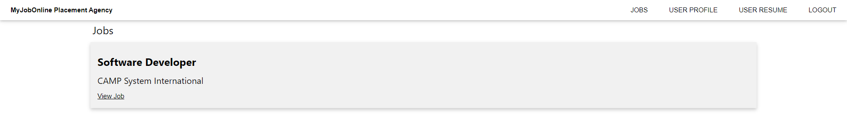

Employee home page displays the list of available job created by the employer. The web page contains four navigation menu.

1. The jobs menu displays the list of jobs.
2. User profile menu has two sub-menu, View profile and Edit profile.
3. User resume menu has three sub-menu, Create/Edit Resume, View Resume and Delete Resume.
4. Logout menu on click will sign out the current user and be navigated to the intro web page.

**USER PROFILE – VIEW PROFILE**

Displays the user details which was entered during registration.

**USER PROFILE – EDIT PROFILE**

Displays the user details in the input field with the values rendered in it for the user to make changes to any of the fields.

**CREATE/EDIT RESUME**

The create/edit resume web page allows user to create and edit the resume for the employee by entering the required details in the input fields.

**VIEW RESUME**

The View resume web page allows the user to view the created resume with a template. This feature is available for both the employee and employer.

**DELETE RESUME**

Delete resume allows the user to delete the employee’s resume when logged in from the specific employee’s credential.

**LOGOUT**

The logout functionality makes the user to sign out from the web application and is navigated to the intro web page.

**EMPLOYER HOME PAGE**

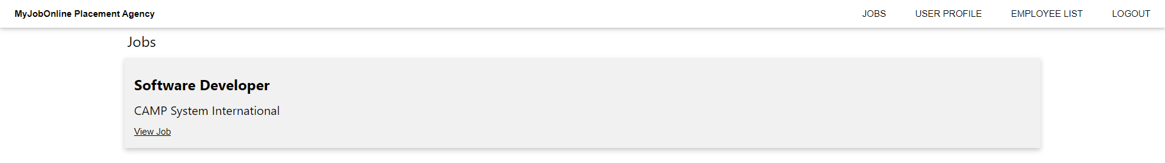

Employer home page displays the list of all the available job created. The web page contains four navigation menu.

1. The jobs menu displays the list of jobs with two sub menus, List jobs and Create job.
2. User profile menu has two sub-menu, View profile and Edit profile.
3. Employee list
4. Logout menu on click will sign out the current user and be navigated to the intro web page.

**EMPLOYER VIEW JOB**

On clicking the view job hyperlink of a specific job, the user is navigated to the view job web page displaying the details regarding the job. This web page contains edit job and delete job buttons.

On click of edit job, the user is navigated to the Edit Job web page where the input fields for editing the specific is displayed with the values rendered in it.

When the delete job button is clicked, the job is deleted from the database and is navigated to the employer home web page.

**JOBS – LIST JOBS**

The list of all available jobs are displayed in this web page.

**JOBS – CREATE JOB**

Helps employer create the job by filling in all the details to post the job for the employee.

**EMPLOYEE LIST**

This web page displays a list of all the employees registered in the website. The employer can search the employee based on the name or skills. The employer is navigated to the view resume web page on clicking the employees name in the list.

All the data’s are stored and retrieved from the Oracle SQL database.